Questions to answer next
Please answer these so I can turn this into a real architecture plan:
- What exact start workflow should the app support?
  - one-button start, multi-stage countdown, cues, manual override, or all of these?
There are 2 parts –
Part 1 -set-up
The race office wants to use a selection of flags and timing, from a list. They drag each element into a grid. The sequence of events is based on the grid

This is the race officers screen
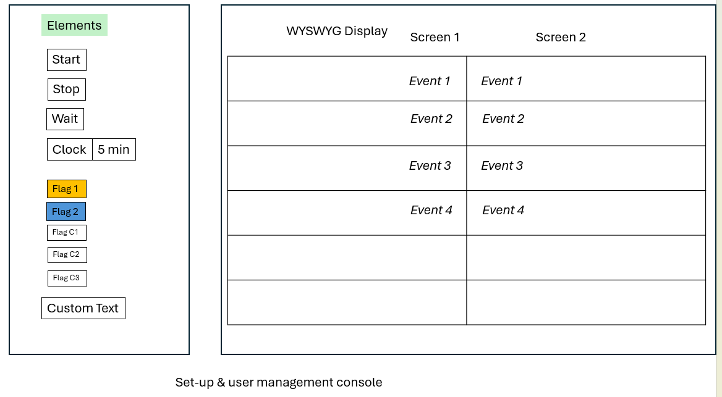As the sequence runs the block running is highlighted

Review https://www.youtube.com/shorts/7H2RZsGK3Jw
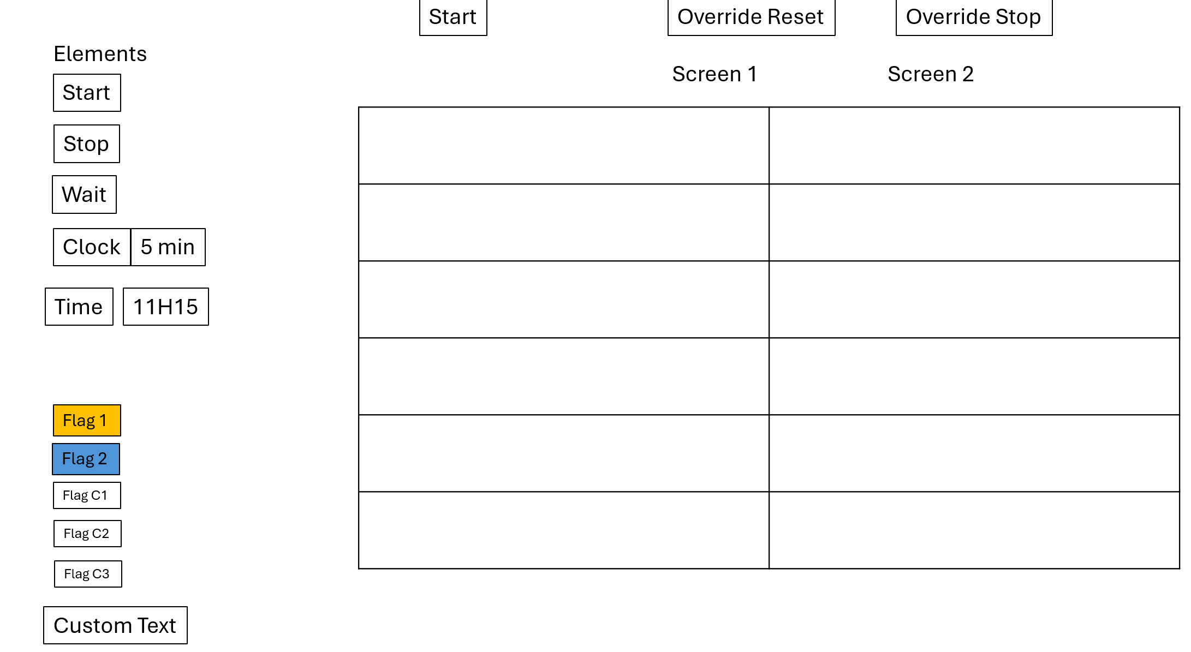
After dragging:

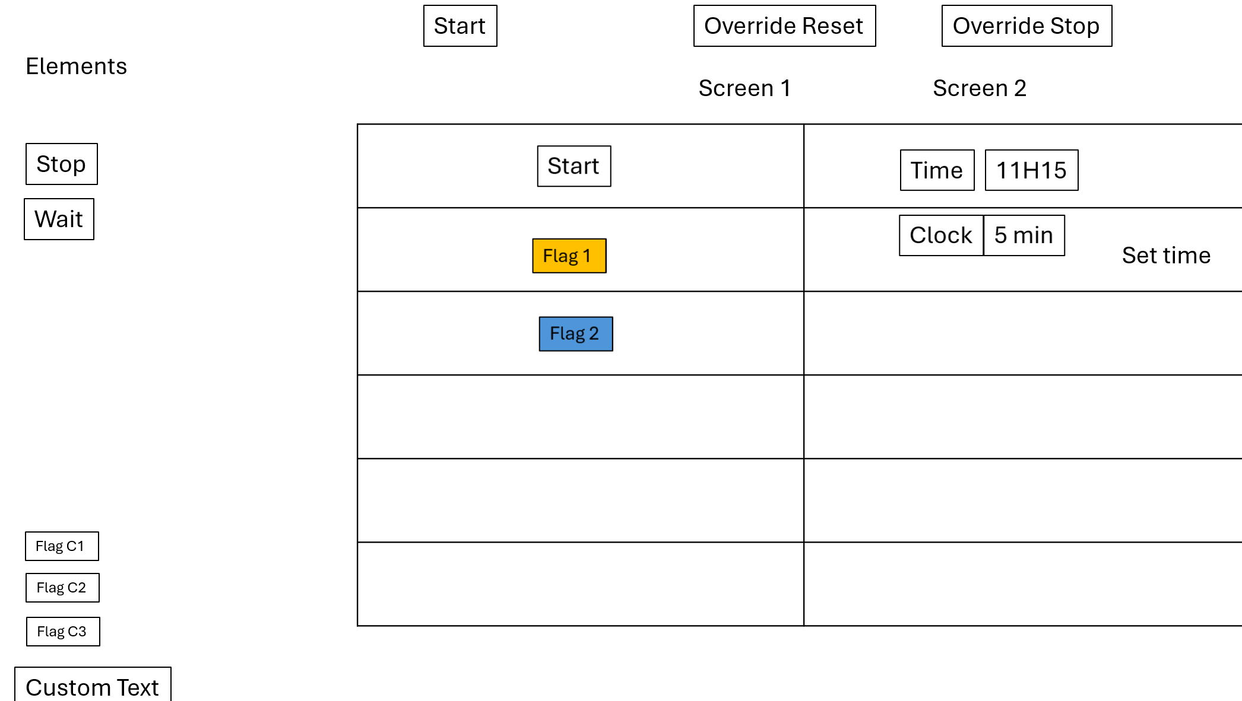
1. Race Officer UI
Touch-screen web application.
Purpose:
- Create race start sequences
- Save templates
- Edit timings
- Re-order steps
- Test sequences
Think:
Plain Text
Toolbox
--------------------------------

Green Flag
Yellow Flag
Blue Flag
Black Flag

Countdown
Delay

Message

--------------------------------

Sequence

[]
[5 Minute Flag]
[Countdown 5:00]
[]
[4 Minute Flag]
[Countdown 4:00]
...

Display board:
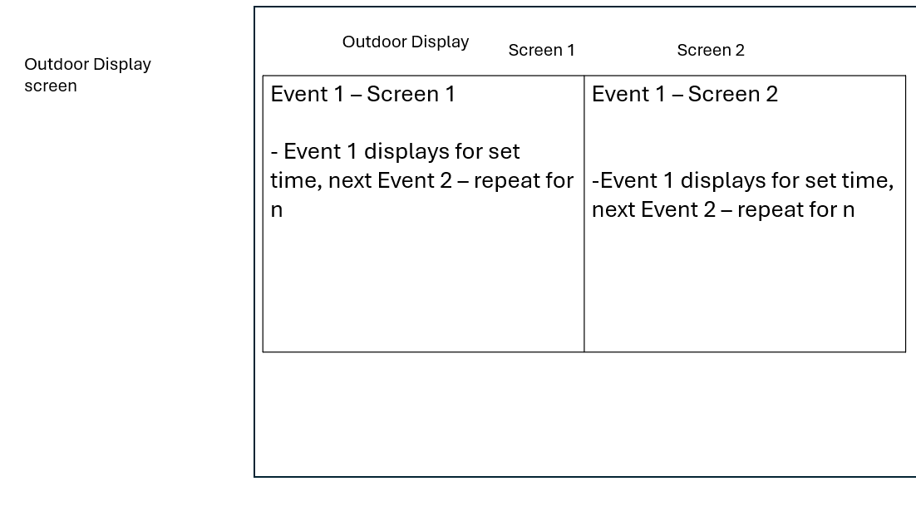

- Is the first version for one race at a time, or should it support multiple saved race templates? – only 1 race, there are multiple classes of boat racing together, typically it is 5 minute from first flag to class 1 start, followed by three minutes till the next class – we have up to 5 classes leaving the start line in 1 race. Once all boats have left the race officer stopr the flag machine, reste when the next race starts later
- Will this run on one screen, or do you want a separate public display for the countdown? The race officer has the control console, and it is a screen share with a display board outside the race tower. ( for now assum is is simply another pc momnitor)
- Do you want a drag-and-drop editor for race stages, or is a form-based setup good enough for v1? Drag and drop is preferred, v1 must be form/dropdown menues
- Are there any required sound cues or external hardware triggers? – not in this version
- Should the interface feel like a modern control dashboard, a race-committee panel, or something more traditional? Very simple design – our race officers want simple big buttons
- Will one operator use it, or do you want a small team workflow with shared control? – 1 operator
- How strict do you need timing accuracy and fail-safe behavior to be? The timing must be linked, when clock 1 for class 1 is complete, clock 2 for class 2 must immediately run, the race officer will have a pause and a stop/reste button. Keep this simple in v1

- Race Configuration System (used by the Race Officer)
- Race Display Engine (used by the outdoor screen)
The key design principle is:
The Race Officer builds a sequence of events. The display engine simply executes the sequence.
Responsibilities:
- Load sequence
- Execute steps
- Maintain clock
- Trigger events
- Maintain state
Example state:
JSON
{
"status": "running",
"currentStep": 4,
"remainingSeconds": 123,
"activeFlag": "yellow"
}
Think of it as a workflow runtime rather than a UI.

4. Outdoor Display
Browser running full-screen.
Display receives state updates.
Shows:
Plain Text
----------------------
5:00
----------------------

[WARNING FLAG]

NEXT SIGNAL:
4 MINUTE FLAG
Show more lines
The display should contain no business logic.
It only renders state coming from the engine.

